

**Flavius’ Rule**

*Emperor Flavius has requested*

*Another gladiator game. You*

*Have been selected for the arena*

*To assemble armor and weapons*

*In hopes to survive the rounds*

*And be crowned Victorious*

*Of Flavius’ Rule*

**Overview**

Flavius’ Rule is a game for 4 players and 1 optional Game Master. Each player will take charge of a different class and attempts to lead their gladiator to greatness.

Starting with a humble set of armor, weapons, and equipment, each player tries to advance their gladiator in several ways: battling vicious animals and spawned opponents, acquiring new armor and weapons, collecting precious gold and items, or gambling by drawing a card.

Ultimately, however, the players’ most difficult challenge is facing each other, as one gladiator collides with another, in hopes to be crowned victorius.

**The object of the game**

Each player can win Flavius’ Rule in one of two ways:

Crowned Victorious: is achieved by surviving against all odds, defeating all players and any spawned NPCs.

PVP Victory: is accomplished by defeating all players.

An optional scoring system is detailed on page

**Components**

The following sections list and describe the physical components of *Flavius’ Rule*.

* This rulebook
* 1 Game Board
* 4 Player Boards
* 2 Market Boards
* 1 Market Rolling Board
* 1 NPC Board
* 4 Turn Reference Cards
* 4 Player Tokens
  + 1 Red Soldier
  + 1 Blue Royalty
  + 1 Green Hero
  + 1 Yellow Slave
* 6 Animal Tokens
  + 2 Snake
  + 2 Wolf
  + 2 Bear
* 4 NPC Tokens
  + 2 Lion
  + 1 Tholo
  + 1 Commodus
* 12 Pillar Tokens
* 12 Blessings of the

People Tokens

* 10 Weapon Spawn Tokens
* 10 Armor Spawn Tokens
* 1 Weapon/Armor Spawn Indicator (6-Sided)
* 10 Health Elixir Tokens
* 10 Armor Scraps Tokens
* 4 Tunnel Tiles (2-Sided)
* 8 Tunnel Key Tokens
* 100 gold coins
* 81 Arena Cards
* 66 Weapon Tokens
  + 33 Large
  + 33 Small
* 61 Amor Tokens
* 1 PVP On/Off Token
* 24 Black Armor Stat pawns
* 24 Health Stat pawns
  + 8 Green
  + 8 Purple
  + 4 Yellow
  + 4 Red
* 10 NPC Health Counter Dice
  + 4x 10-Sided
  + 4x 6-Sided
  + 2x 20-Sided
* 4 Ammo Count Dice (8-Sided)
* 1 Chest Die (6-Sided)
* 1 Chest Board
* 4 Corpse Tokens
  + Red Corpse
  + Blue Corpse
  + Green Corpse
  + Yellow Corpse
* 2 Grid Location Dice
  + 1 A-M (12-sided)
  + 1 1-12 (12-sided)
* 1 Hit Locator Die (6-Sided)
* 16 Hit Dice (6-Sided)

**Component Descriptions**

This section identifies each component of *Flavius’ Rule*.

**Game Board**

The game board consists of a 13x13 square tile grid. Dashed lines mark zones for animals and rounds. 1-12 and A-M mark the sides to indicate locations in the arena grid.

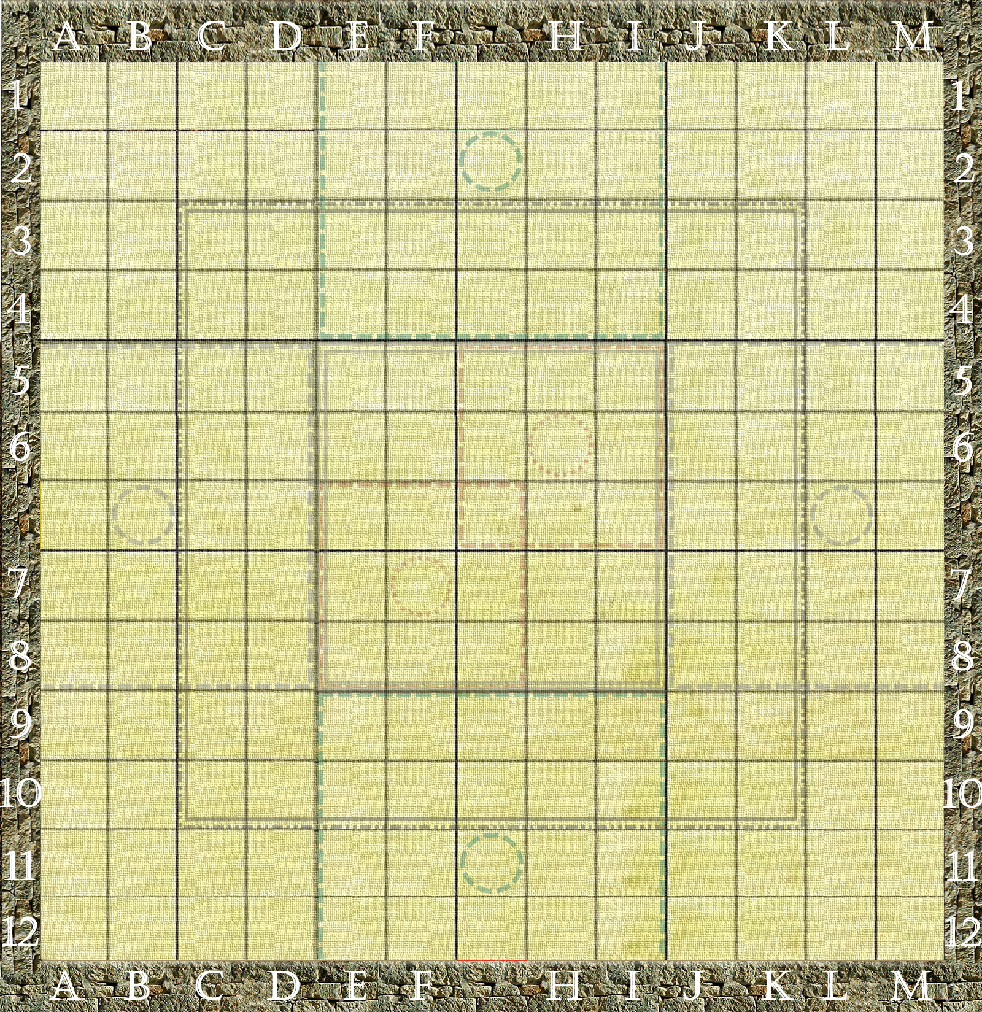

**Player Boards**

Boards are managed by players to keep track of health and armor stats, weapons, items, and cards.

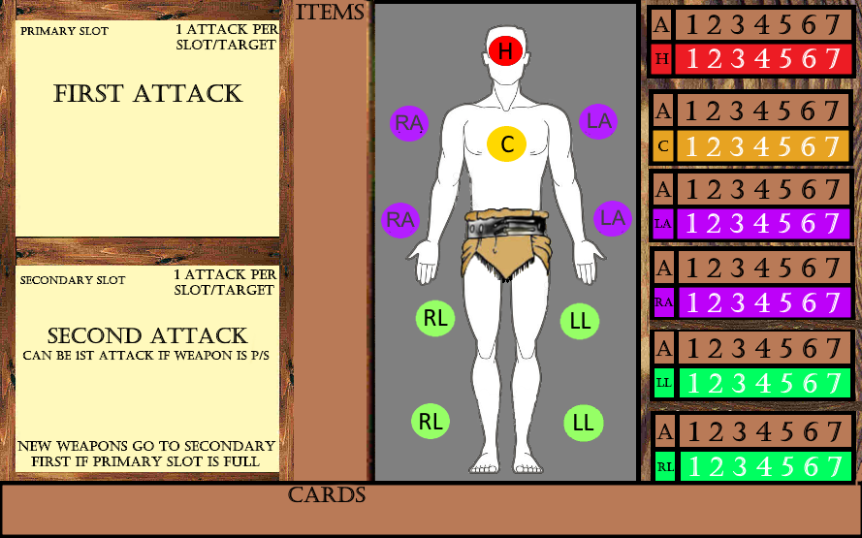

**Market Boards / Die**

Weapons and Armor can be acquired via the market boards by rolling the market die. For full details, see p.

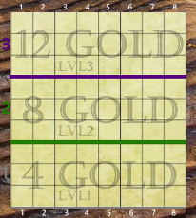

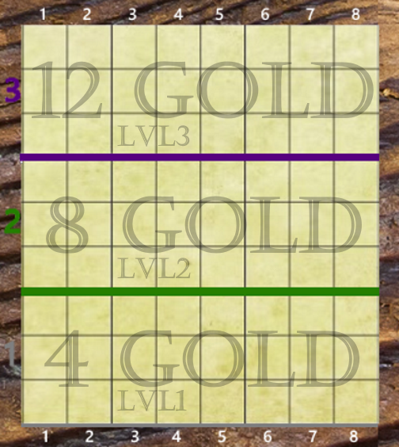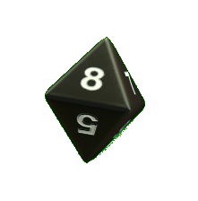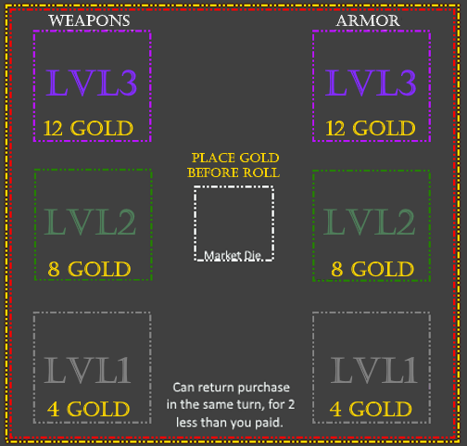

**Player Tokens**

Player tokens keep track of the player while they are in the arena grid.

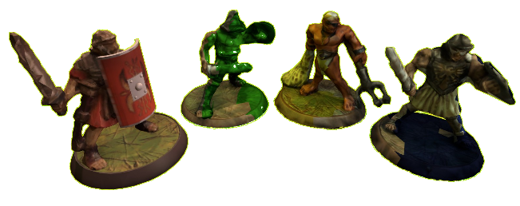

**NPC board And Health Counter Dice**

Use the NPC board to track the health of any animal or NPC using the health counter dice.

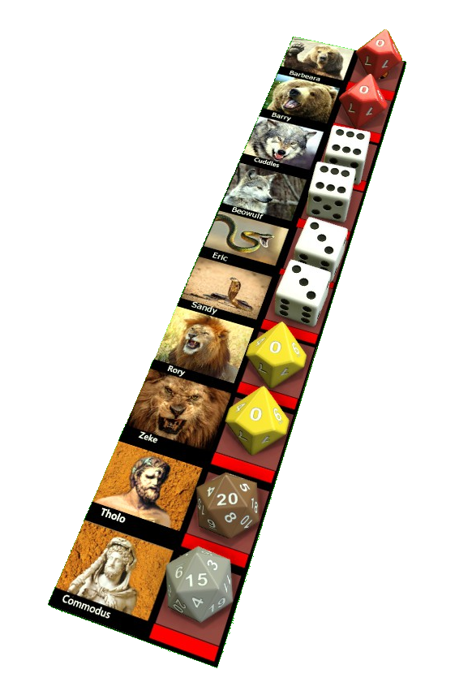

**Turn Reference cards**

Turn reference cards are used by players to understand the order in which they carry out tasks on their turn.

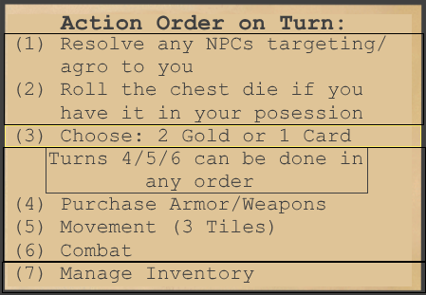

**Animal Tokens**

Animal tokens keep track of the snakes, wolves, and bears that start the game in the arena.

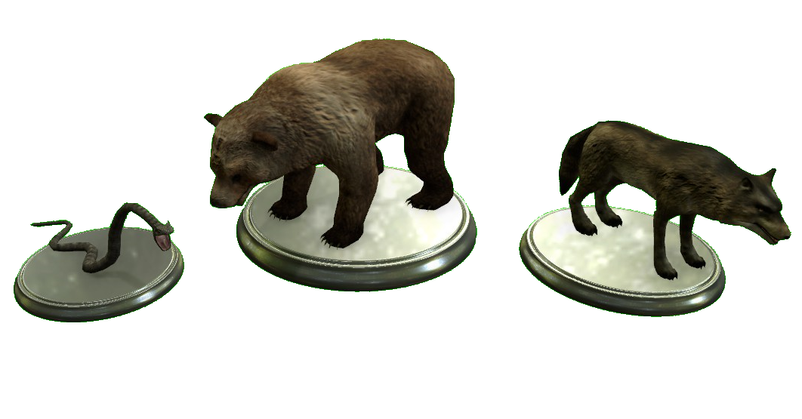

**NPC Tokens**

NPC tokens keep track of Tholo, the Lions, and Commodus once they spawn into play.

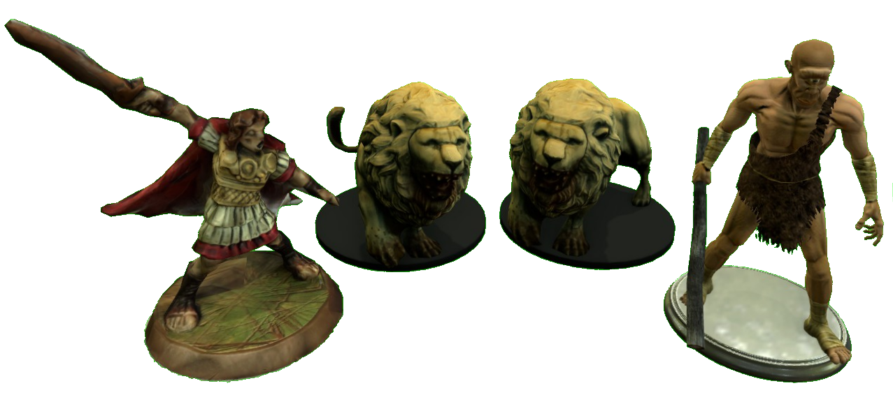

**Pillar Tokens**

Pillar tokens are pushed around the arena grid by players. The colors represent the different zones for each round. For full details on pillars, see page

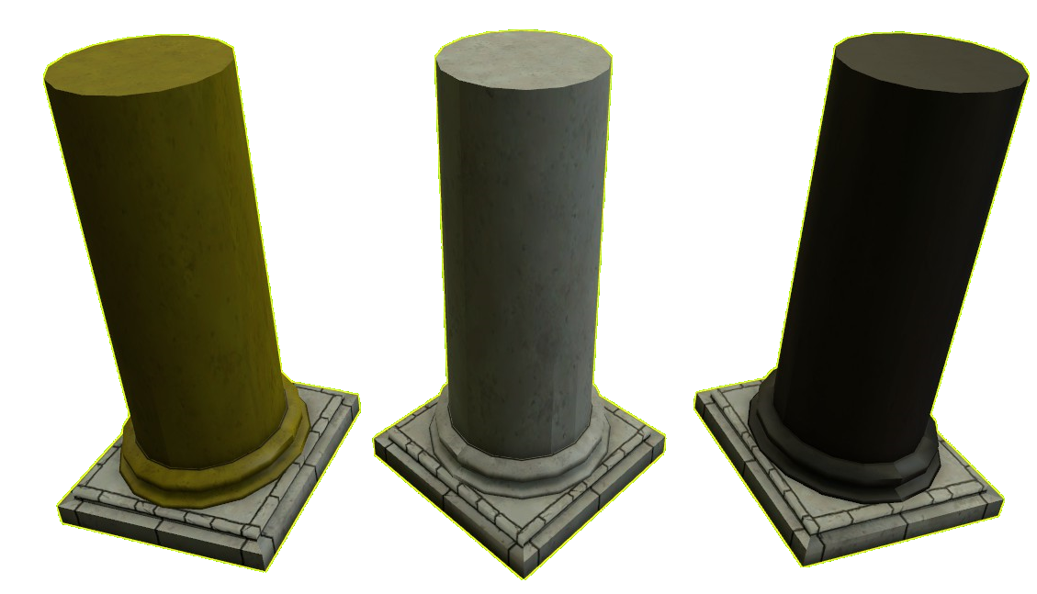

**Blessings of the**

**people tokens**

These tokens lie under unmoved pillars within the arena grid. For full details, see page

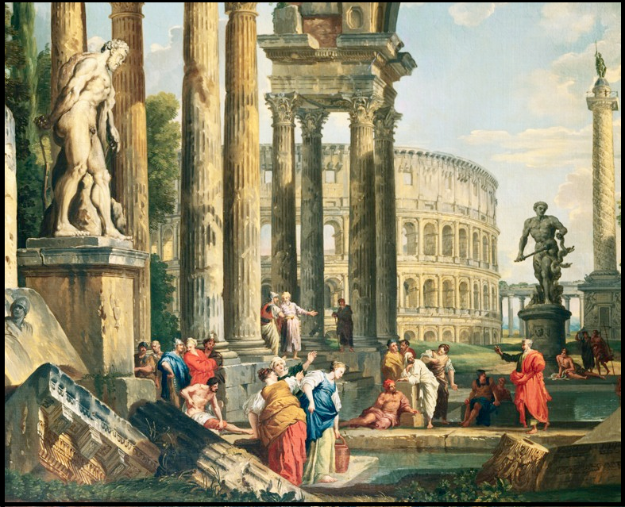

**Weapon and Armor spawn tokens and DIe**

Weapon and Armor tokens can by picked up by players around the arena grid. For full details, see page

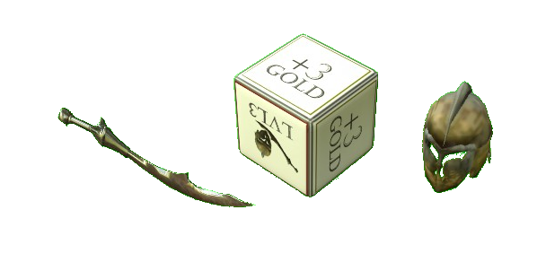

**Health Elixir and Armor Scrap Tokens**

These tokens can be picked up by players within the arena grid. For more details, see page

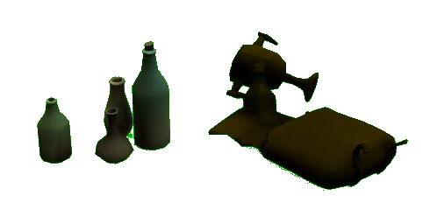

**Tunnel Tiles and**

**Key Tokens**

Tunnel tokens can be found around the arena grid and can be used with tunnel key tokens. For full details, see page

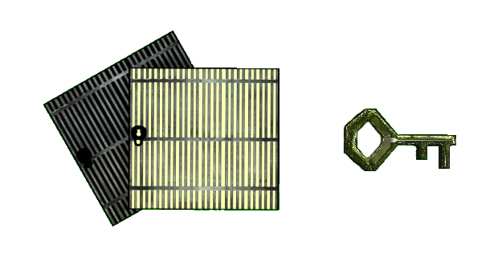

**Weapon Tokens**

Weapon tokens are used for the market and arena grid and can be equipped to the player board. For full details, see page

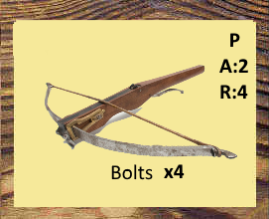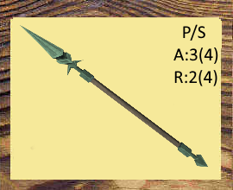

**Armor Tokens**

Armor tokens are used for the market and arena grid and can be equipped to the player board. For full details, see page

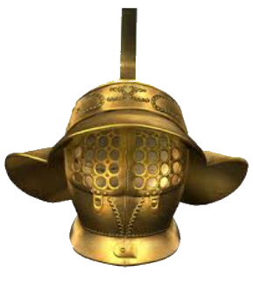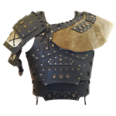

**Armor and Health**

**Stat Pawns**

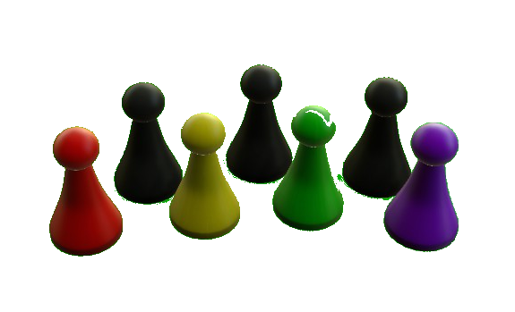These pawns track the health and armor stats of your gladiator.

**Arena Cards and**

**Gold Coins**

Arena cards have a variety of effects and are designed to hurt or help the player. Gold is used for the market.

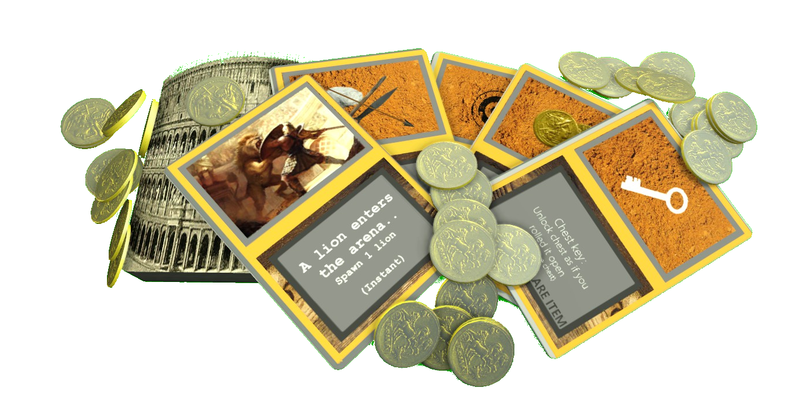

**PVP on/oFF token**

This token can be flipped to let players know if PVP is on or off.

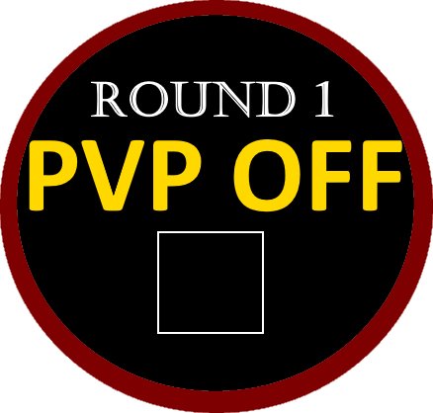

**Ammo Dice and**

**Aggro Tokens**

Keep track of ammo counts and NPC player aggro direction.

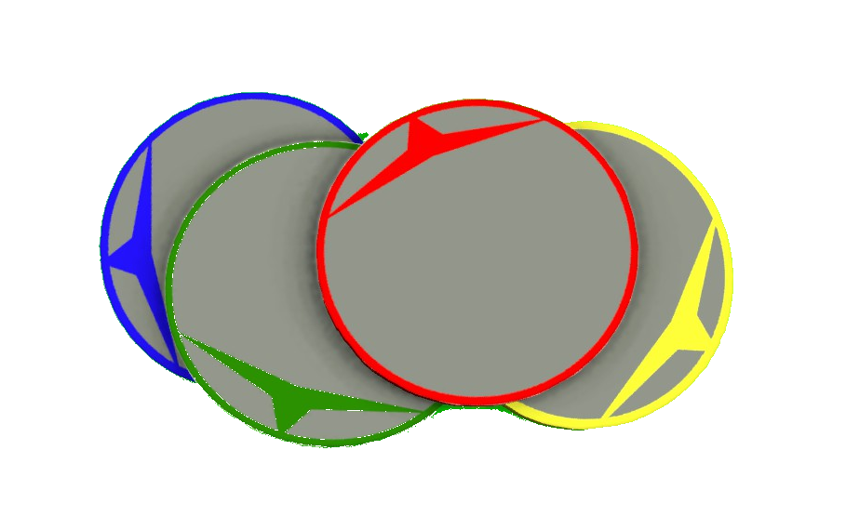

**Chest Dice and Board**

The chest dice starts the game in the center of the arena grid and can be picked up by players. For full details, see page

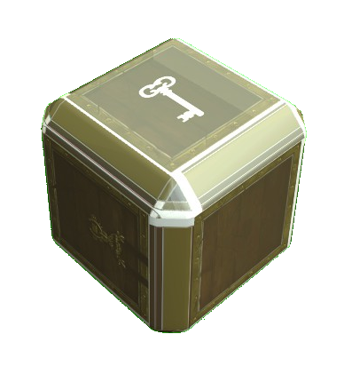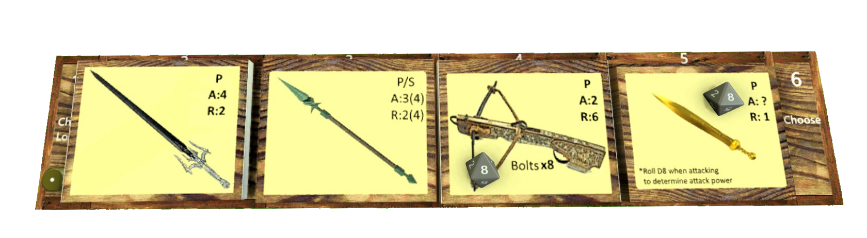

**Corpse Tokens**

Corpse tokens are dropped into play when a player is killed. For full details, see page

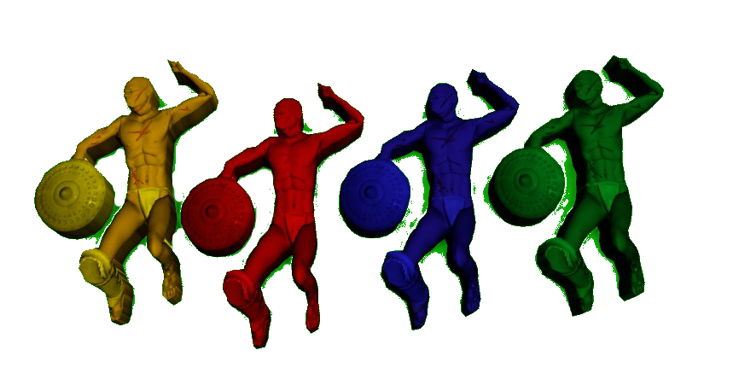

**Grid Location Dice**

These dice are used to spawn in items and NPCs to the arena grid.

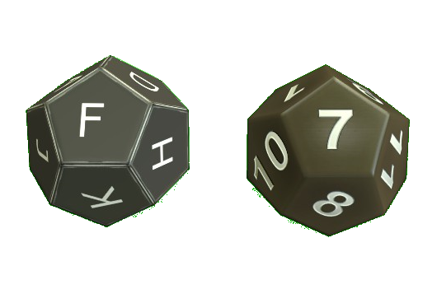

**Hit & hIT Location Dice**

The hit location die is rolled to determine where on the body the attack is targeting. Hit dice are rolled to see if that body part is hit. For full details, see page

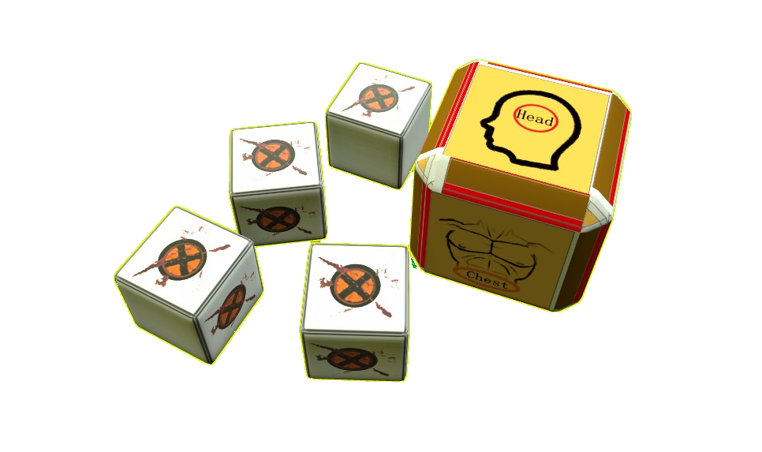

**Player Boards and arena Grid breakdown**

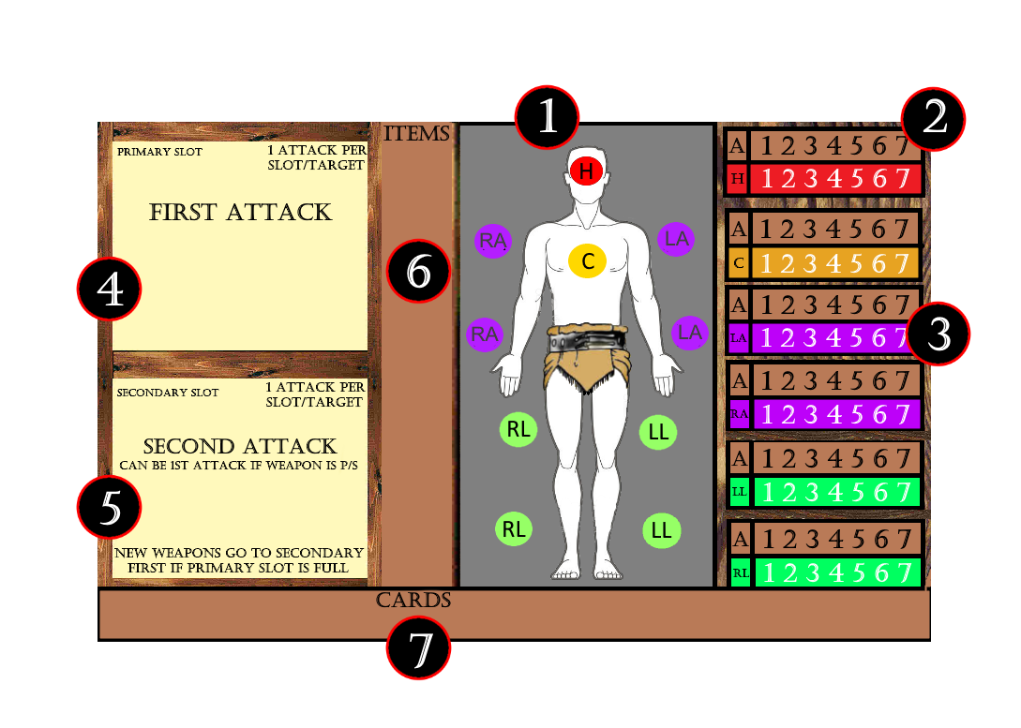

Every player card

contains the outline of

a gladiator **(1)**, an

armor stat **(2)** and

health stat **(3)** for

each body part, a

primary **(4)** and

secondary **(5)** attack,

and space to keep

items **(6)** and cards **(7)**

The board is a 13x13

square tile grid that has

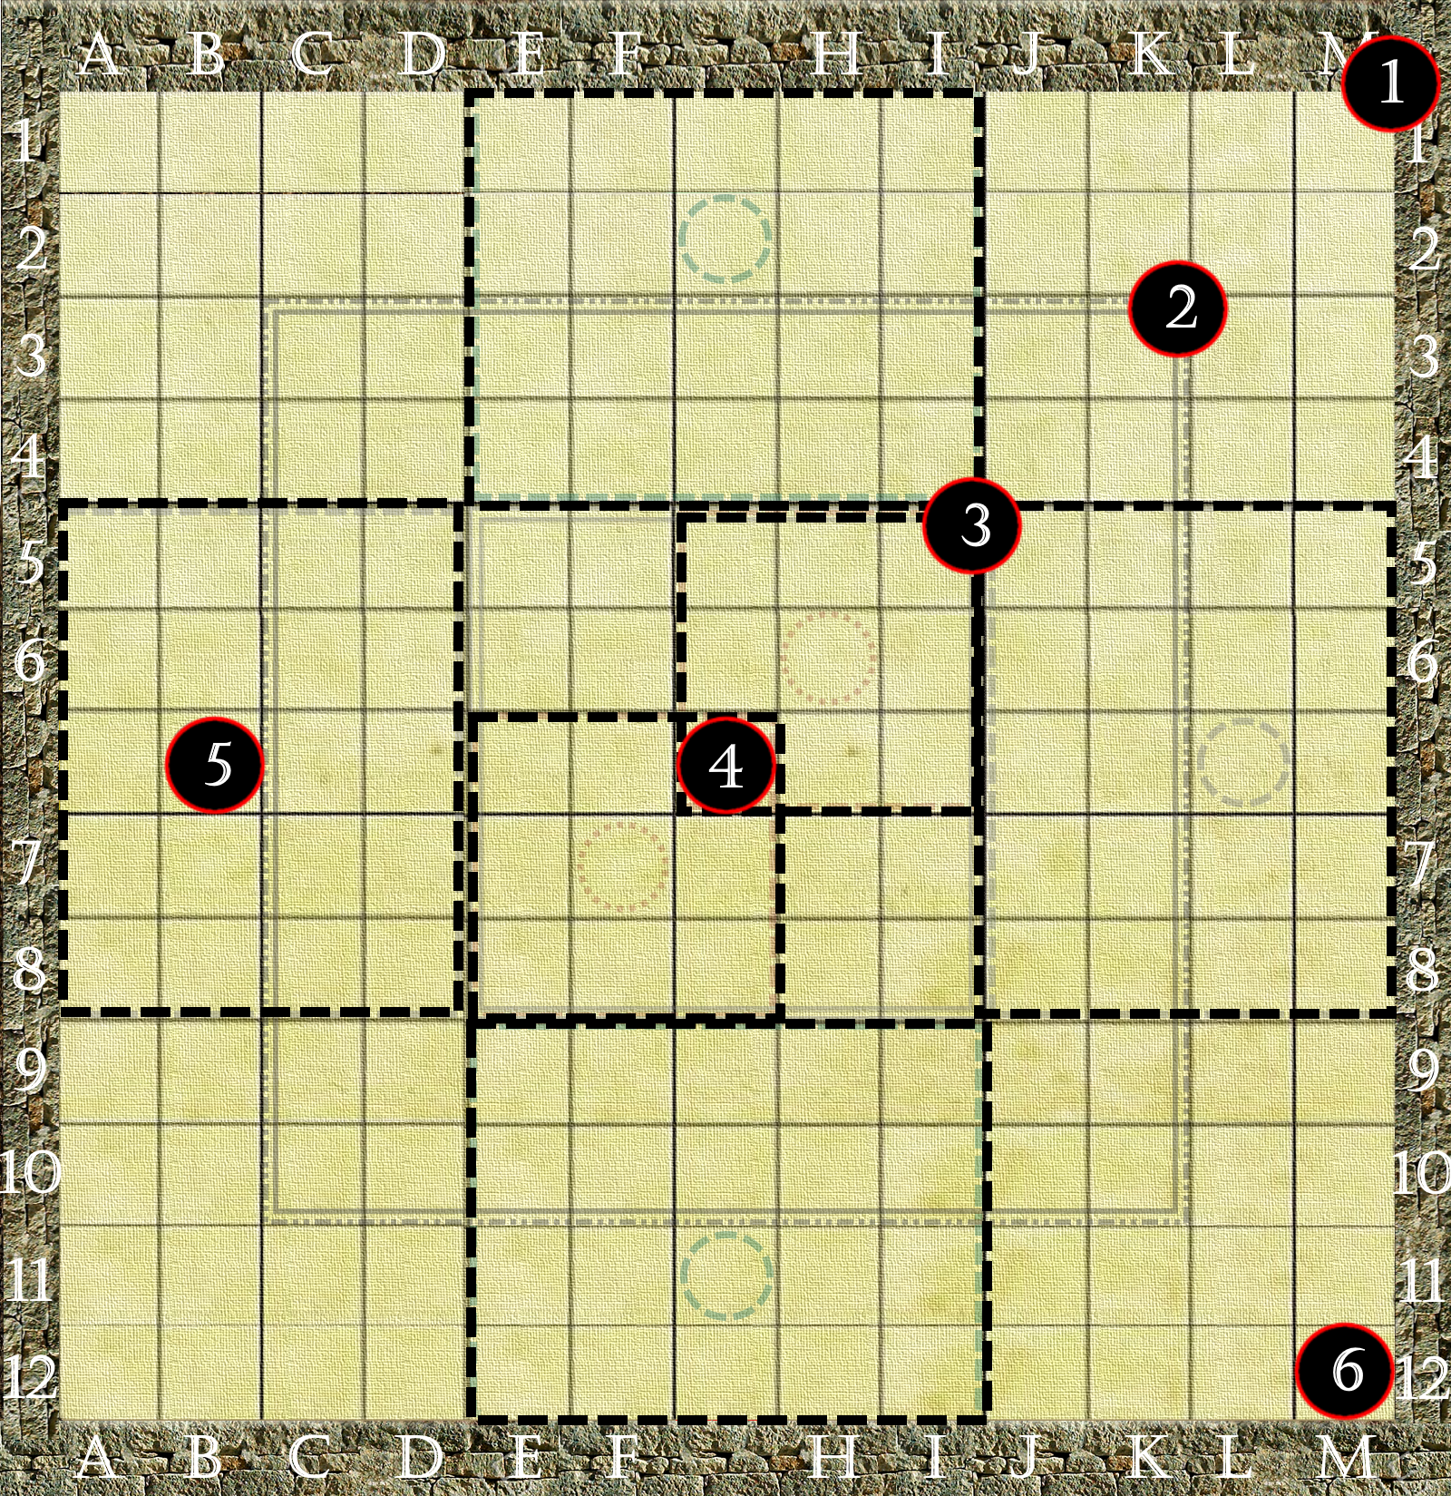

three zones. Zone **(1)** takes

up the entire arena,

Zone **(2)** which shrinks to a

9x9 grid indicated by the

double lines, and lastly

Zone **(3)** forces fighters to

the center of a 5x5 arena.

The chest **(4)** starts the

game in the center of the

arena, and starter animals

all have their own zones **(5)**

to monitor shown with the

dashed lines. Each player

starts the game in their own

corner **(6)**.





**Preparing for**

**the first Game**

Before playing Flavius’ Rule for the first time, carefully punch out the cardboard components, making sure to keep them away from small children and animals.



**General Setup**

This section explains the general setup of the game. .

1. **Choose Class**

Each player chooses the class they wish to play as for the entire game.

**Retiarii-Yellow**

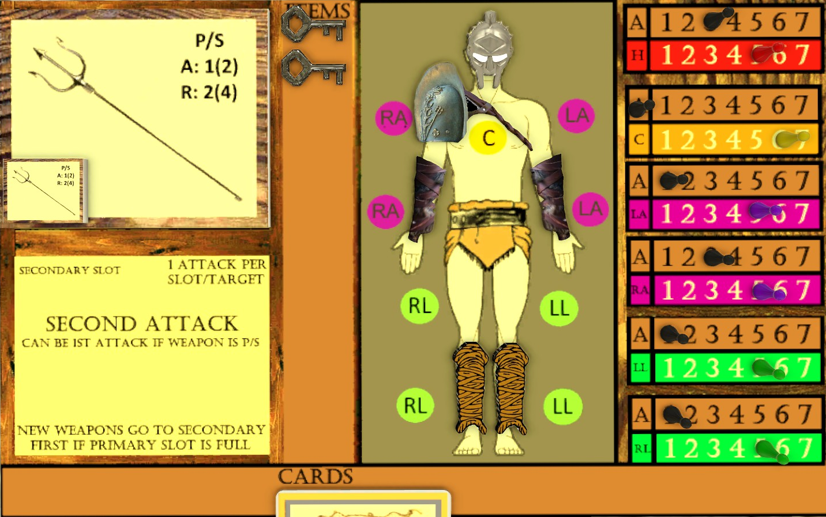

.

Player yellow starts with a trident (A:1(2) | R:2(4), Retiarii shoulder (+2 arm armor. +1 head), fur bracers (+1 each arm armor), gladiator helm (+2 head armor), a net card, 2 tunnel keys, and 3 gold. For the first round, Retiarii gains +1 movement each turn.

**Legionaire-Red**

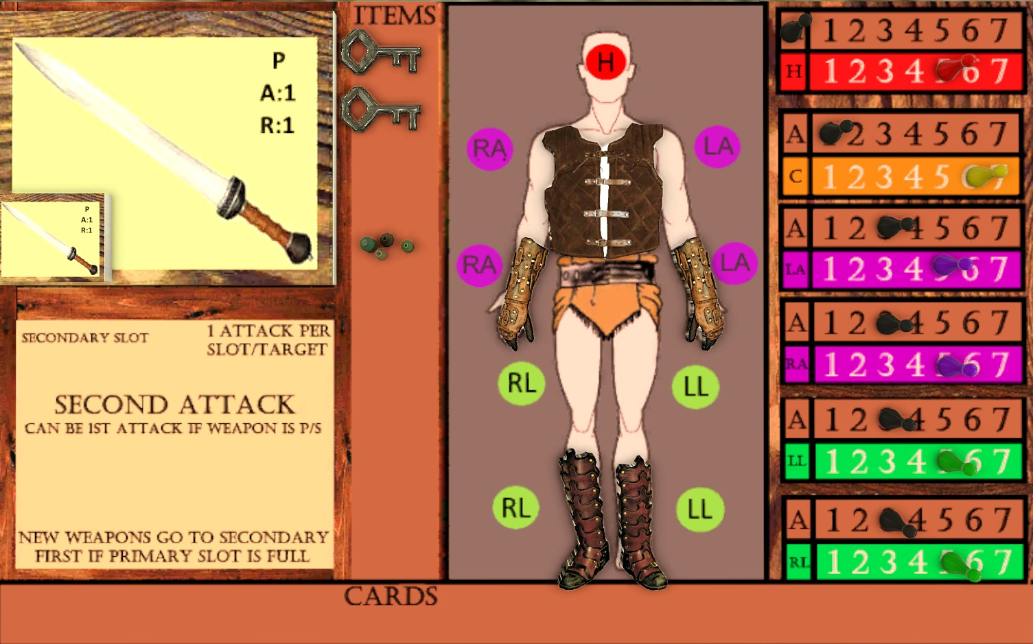

Player red starts with a Gladius (A:1 | R:1), leather vest (+1 chest armor), leather gloves and boots (+3 to each arm and leg armor), 1 health elixir, 2 tunnel keys, and 3 gold. For the first round, the Legionaire adds +1 to any damage dealt.

**Royalty-Blue**

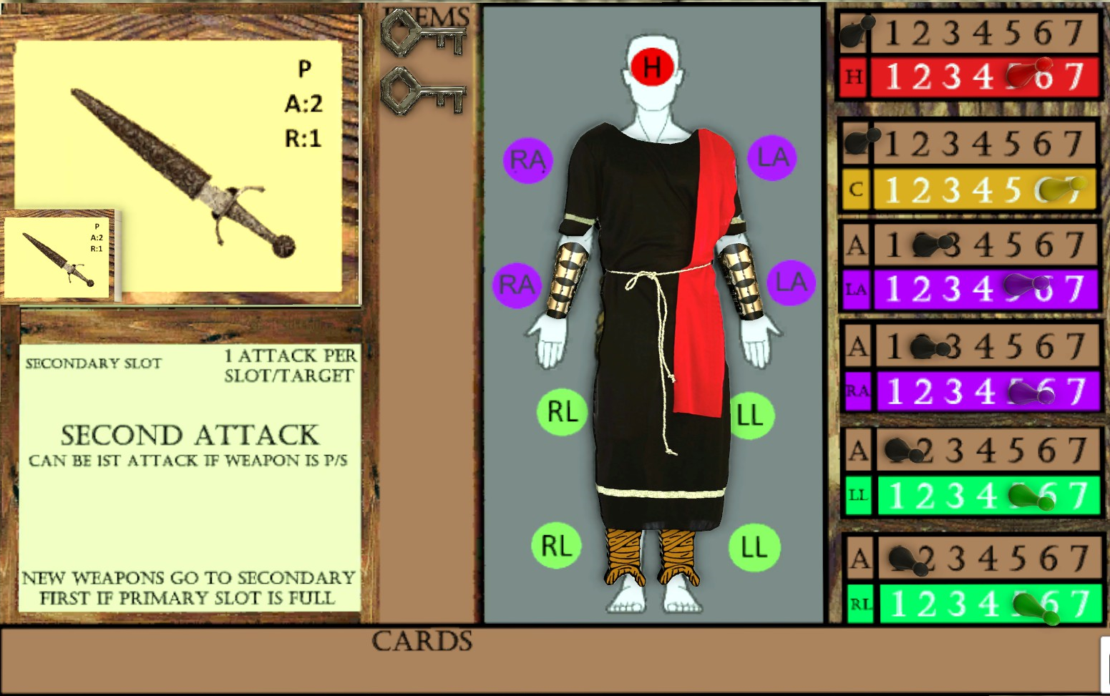

Player blue starts with a dagger (A:2 | R:1), steel bracers (+2 to each arm armor), cloth wraps(+1 to each leg armor), 2 tunnel keys, and 3 gold. For the first round, Royalty collects 1 gold to start their turn.

**Hero Provocator-Green**

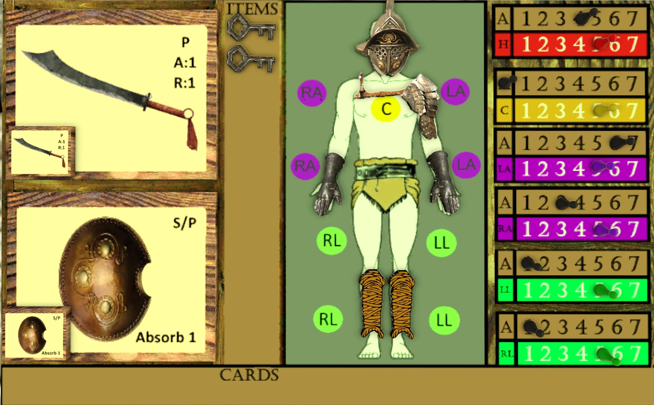

The hero starts with a (A:1 | R:1) of their choice, shield (absorb 1), iron grieves (+3 each arm armor), Sentinel shoulder(+3 to one arm armor), Provocator helm (+4 head armor), cloth wraps (+1 each leg). 2 tunnel keys, and 0 gold. The Hero does not have a round 1 bonus.



1. **Distribute player components**

Each player takes the following:

* 1 player board
* Class loadout of armor, weapons, items, cards, and gold.
* 6 health stat pawns
* 6 armor stat pawns
* 4 Hit Dice
* 1 Turn Reference card
* 1 Player Token to place in corner of arena nearest you.

1. **Set up market board**

Players can set up each market board by placing armor and (small)weapon tokens in any desired slots based on their level, or use the provided exampled in the back of the rulebook. Place 1 8-sided die on the market rolling board and keep it close by.

1. **Set up NPC board**

Place NPCs tokens (not in play) and health counters on the slots next to their portraits.

1. **Set up Chest board**

The chest board can be kept above the market with 1 6-sided die, 2 8-sided dice, and the LVL 4 weapons placed in any slots.

1. **Set up Arena Grid**

Armor and Health

Stat Pawns

These pawns track the health and armor stats of your gladiator.

Armor and Health

Stat Pawns

These pawns track the health and armor stats of your gladiator.

Armor and Health

Stat Pawns

These pawns track the health and armor stats of your gladiator.

Armor and Health

Stat Pawns

These pawns track the health and armor stats of your gladiator.

**Armor and Health**

**Stat Pawns**

These pawns track the health and armor stats of your gladiator.

**Armor and Health**

**Stat Pawns**

These pawns track the health and armor stats of your gladiator.

Wwwwwwwwwwwwwwwwwwwwwwwwwwwwwwwwwwwwwwww wwwwwwwwwwwwwwwwwwwww

**NPC Tokens**

The following sections list and describe the physical components of Flavius’ Rule.

Armor and Health

Stat Pawns

These pawns track the health and armor stats of your gladiator.

Armor and Health

Stat Pawns

These pawns track the health and armor stats of your gladiator.

Armor and Health

Stat Pawns

These pawns track the health and armor stats of your gladiator.

Armor and Health

Stat Pawns

These pawns track the health and armor stats of your gladiator.

Armor and Health

Stat Pawns

These pawns track the health and armor stats of your gladiator.

Armor and Health

Stat Pawns

These pawns track the health and armor stats of your gladiator.

Wwwwwwwwwwwwwwwwwwwwwwwwwwwwwwwwwwwwwwww wwwwwwwwwwwwwwwwwwwww

NPC Tokens

The following sections list and describe the physical components of Flavius’ Rule.